Standard Work Instruction
Process: |  |  |  | Version:
Symbols | 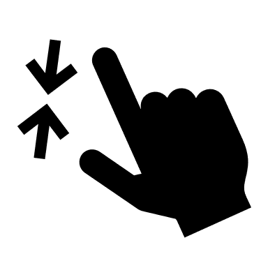  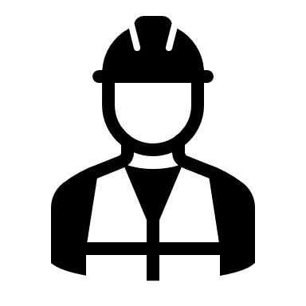  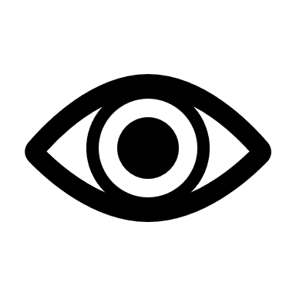  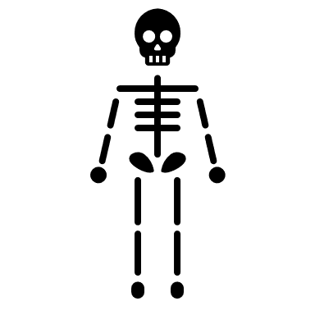  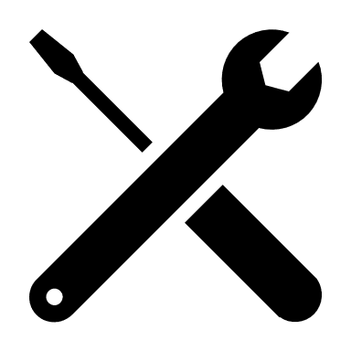  PPE Required  Physical Check  Visual Check  Quality Check  Ergonomics/Health  Safety Check  Tools
Process Step | Time (Minutes) | Symbol | Operation Step | Picture Number | Pictures

